ADALM PLUTO
Just like Pluto (the celestial body) is a Dwarf Planet, resembling a small planet.
2 RF SMA connectors ¹⁾ to connect to instrumentation or an antennas
  - Transmit (labeled 'Tx')
  - Receive (labeled 'Rx')
  - 300 MHz - 3.8 GHz
  - 200 kHz - 20 MHz channel bandwidth
  - the 192.168.2.1 IP address by default.
  - External power: It was a possibility during the design of Pluto
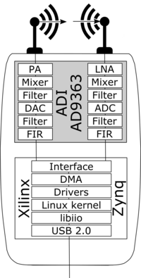
The radio inside the ADALM-PLUTO is the AD9363:
- The receive subsystem includes: LNA, mixer, configurable analog filters, a high-speed ADC, digital decimation filters, and a 128-tap FIR filter to produce a 12-bit output signal at the appropriate sample rate. The receive chain is augmented with configurable automatic gain control (AGC) or manual gain control modes, dc offset correction, and quadrature correction. The resulting received I and Q signals are passed onto the digital baseband processor, in this case the Xilinx Zynq SoC.
- The transmit accepting 12-bit I and Q samples from the baseband processor (in this case, the same Xilinx Zynq SoC), it runs them through a 128-tap finite impulse response (FIR) filter, digital interpolation filters, a high speed DAC, an analog filter, the direct conversion mixers, and through a small power amplifier (PA) out to the antenna.
- Fully integrated phase-locked loops (PLLs) inside the AD9363 provide clocks and local oscillators for receive and transmit channels, and clocks for the ADC, DAC and output sample rate.

Transmit Architecture
The AD9363 transmit chain is based on Direct Conversion techniques. Although this block diagram is for the AD9361, it is also appropirate for the AD9363 found inside the ADALM-PLUTO. The differences between the two units are the tuning range and minor missing features (DCXO, external LO are missing, and the RF channel bandwidth is reduced).
Run the DACs as close to full scale as you can, and then turn up/down the output attenuation to vary the output signal strength. (Don't just decrease the input to the DAC). Full scale into the DAC is 12 bits, but to supply a full scale signal using HDL provided by ADI will actually require a 16 bit signal to be provided, where the lower 4 LSBs are removed.

